Technical Report

Course assignment for Design Course

Sayed Nabil Habib

Word count

Summary: 182 | Main text:720

Table of Contents

1. Summary 3

2. Body 3

2.1. Introduction 3

2.2. Main section of report 4

2.3. Conclusion 6

4. Acknowledgements 6

5. Links 6

# 1. Summary

# This report covers progress on the design work from the sketch to the final version, which is the prototype. The overall goal of this report is to show what we have learned through the 5 weeks of the design course, and how to implement the knowledge in real-life problems.

# The Design is made in Figma application and inspired by some real-world projects, such as Netflix and other similar websites, the vision of the design is to be simple and quick for the visitors who want to have easy and fast access to the movies or series listed on the website.

# In the Design course, we have learned all about the design fundamentals, including content management, colors, typography, fonts, etc.. also the last two modules were about the user interface and user experience which include designing and prototyping. Together with all this information and knowledge, we were able to design our projects and therefore I selected the Square Eyes and develop the design in Figma application for the web and phone versions. I design two separate files for web and phone versions.

# 2. Body

## 2.1. Introduction

The purpose of this report is to explain the process of my projects step by step in words, I am going to explain all my work from hand-drawn wireframes to digital wireframing and interaction of the design work. We are going to explain, why I have selected the Square eyes projects, how to start the design idea, which steps I took to see the final version of the project, etc...

During the design process, I used the popular Figma application to design the project, besides this I used adobe illustrator and photoshop, in some parts of the project to deliver the desired design.

## 

## 2.2. Main section of the report

## After reviewing the options for the final course assignment, I have selected the Square Eyes project, square Eyes was an interesting work for me, which I saw I can build something cool and enjoy at the same time, and I could see similar websites to the square eyes in the real world and what I could wish to change and what could be better from my point of view, for example, scrolling the Disney on TV can be sometimes challenging and it is not very clear for the visitor, they are pushing more movies in a single page while looking for a movie in their application on TV. Although Netflix is easier and more accessible.

I start the design process after getting some inspiration from similar websites, I process the information and analyze, it to have an overview of the similar web pages and the target market. I start designing on paper,hand-wireframing, I design all the necessary pages very simple and easy both for web and phone versions, and here I decided on the layout. Below you can find an example of the hand-designed version of my project.

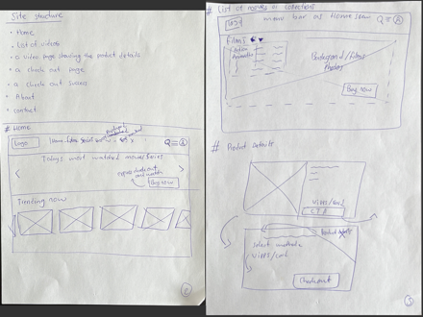

The second step was to design the Digital wireframes, so I start to design digital wireframes using the freehand inVision tool, here I could see my project much better and already have a very clear view of what will be the check-out of the design, I could still do some changes and make adjustments to the design. So once I was done with this step I start the final design in Figma and the last step prototype and sharing with other colleagues for peer feedback, but before I start to explain I would show the second step by some screenshots below,Graphical user interface, application

The last step started after I made changes and reconsider some parts of the design in the second step, here I decided on colors, fonts style, user interface standards, Headers, Navigation, content boxes, placement of texts, elements, search fields, buttons and call to action buttons, etc.. later when done with the designing I start the prototype process, I try to use the easy and simple way to prototype my work using for example components, here is some example of my last version of design and prototype.

In the end, I reviewed all the work and made sure that everything work smoothly and was placed perfectly.

## 

## 2.3. Conclusion

As we started our journey to become a front-end developer, and of course started with the design course, therefore I focused on what we have learned during the course and tasks that we have done at the end of each module and use that knowledge in my assignment. I went through all the processes and implement all the steps to design a website and mobile version according to the market standard and our studies guidelines. In General, the process included many different steps from the research target group to designing the first pages of my webpage, then designing the digital version of the work, and the last part designing the final version and prototype of the work.

The Square Eyes assignment is now ready to submit.

# 4. Acknowledgements

At the end of this course, I would like to thank our teacher Bonita Diener and all the other teachers and responsible people who helped us to complete the design course here at Noroff school of technology.

# 5. Links

**Desktop version:**

https://www.figma.com/proto/sTOinOIm9jrxWCXF7aJ2cs/Course-assignment?page-id=0%3A1&node-id=7%3A144&viewport=-1030%2C310%2C0.51&scaling=min-zoom&starting-point-node-id=1%3A2

**Mobile version:**

https://www.figma.com/proto/vOCS2jB72RPFHwIkR84loZ/Untitled?page-id=0%3A1&node-id=1%3A2&viewport=668%2C382%2C0.32&scaling=scale-down&starting-point-node-id=16%3A197